|  |  |  |  |  |
| --- | --- | --- | --- | --- |
| **VAIRĀK,** |  | **MAZĀK,** |  | **TIKPAT** |
|  |  |  |  |  |
| **>** |  | **<** |  | **=** |

# > < =

**3>1 1<2 2=2**

# SKAITĻU STARS

0 1 2 3 4 5 6 7 8 9 10

0 1 2 3 4 5 6 7 8 9 10 11 12 13 14 15 16 17 18 19 20

**SKAITĻU SASTĀVS**

|  |  |  |  |  |  |  |  |  |  |  |  |  |  |  |  |  |  |  |  |  |  |  |  |  |  |  |  |  |  |  |  |  |  |  |  |  |  |  |  |  |  |  |  |  |  |  |  |  |  |  |  |  |  |  |  |  |  |  |  |  |  |  |  |  |  |  |  |  |  |  |  |  |  |  |  |  |  |  |  |  |  |  |  |  |  |  |  |  |  |  |  |  |  |  |  |  |  |  |  |  |  |  |  |  |  |  |  |  |  |  |  |  |  |  |  |  |  |  |  |  |  |  |  |  |  |  |  |  |  |  |  |  |  |  |  |  |  |  |  |  |  |  |  |
| --- | --- | --- | --- | --- | --- | --- | --- | --- | --- | --- | --- | --- | --- | --- | --- | --- | --- | --- | --- | --- | --- | --- | --- | --- | --- | --- | --- | --- | --- | --- | --- | --- | --- | --- | --- | --- | --- | --- | --- | --- | --- | --- | --- | --- | --- | --- | --- | --- | --- | --- | --- | --- | --- | --- | --- | --- | --- | --- | --- | --- | --- | --- | --- | --- | --- | --- | --- | --- | --- | --- | --- | --- | --- | --- | --- | --- | --- | --- | --- | --- | --- | --- | --- | --- | --- | --- | --- | --- | --- | --- | --- | --- | --- | --- | --- | --- | --- | --- | --- | --- | --- | --- | --- | --- | --- | --- | --- | --- | --- | --- | --- | --- | --- | --- | --- | --- | --- | --- | --- | --- | --- | --- | --- | --- | --- | --- | --- | --- | --- | --- | --- | --- | --- | --- | --- | --- | --- | --- | --- | --- | --- | --- | --- |
| |  |  | | --- | --- | | **1** | | | 1 | 0 | | |  |  | | --- | --- | | **2** | | | 1 | 1 | | 2 | 0 | | |  |  | | --- | --- | | **3** | | | 1 | 2 | | 2 | 1 | | 3 | 0 | | |  |  | | --- | --- | | **4** | | | 1 | 3 | | 2 | 2 | | 3 | 1 | | 4 | 0 | | |  |  | | --- | --- | | **5** | | | 1 | 4 | | 2 | 3 | | 3 | 2 | | 4 | 1 | | 5 | 0 | | |  |  | | --- | --- | | **6** | | | 1 | 5 | | 2 | 4 | | 3 | 3 | | 4 | 2 | | 5 | 1 | | 6 | 0 | | |  |  |  |  |  | | --- | --- | --- | --- | --- | | **7** | |  | **8** | | | 1 | 6 | 1 | 7 | | 2 | 5 | 2 | 6 | | 3 | 4 | 3 | 5 | | 4 | 3 | 4 | 4 | | 5 | 2 | 5 | 3 | | 6 | 1 | 6 | 2 | | 7 | 0 |  | 7 | 1 | |  | | | 8 | 0 | | |  |  | | --- | --- | | **9** | | | 1 | 8 | | 2 | 7 | | 3 | 6 | | 4 | 5 | | 5 | 4 | | 6 | 3 | | 7 | 2 | | 8 | 1 | | 9 | 0 | | |  |  | | --- | --- | | **10** | | | 1 | 9 | | 2 | 8 | | 3 | 7 | | 4 | 6 | | 5 | 5 | | 6 | 4 | | 7 | 3 | | 8 | 2 | | 9 | 1 | | 10 | 0 | |

|  |  |  |  |  |  |  |  |  |
| --- | --- | --- | --- | --- | --- | --- | --- | --- |
|  |  |  |  |  |  |  |  |  |

**PĀRA UN NEPĀRA SKAITĻI**

|  |  |  |  |  |  |  |  |  |  |  |
| --- | --- | --- | --- | --- | --- | --- | --- | --- | --- | --- |
| **0** | **1** | **2** | **3** | **4** | **5** | **6** | **7** | **8** | **9** | **10** |
|  |  |  |  |  |  |  |  |  |  |  |

**SIMTA KVADRĀTS**

|  |  |  |  |  |  |  |  |  |  |
| --- | --- | --- | --- | --- | --- | --- | --- | --- | --- |
| **1** | **2** | **3** | **4** | **5** | **6** | **7** | **8** | **9** | **10** |
| **11** | **12** | **13** | **14** | **15** | **16** | **17** | **18** | **19** | **20** |
| **21** | **22** | **23** | **24** | **25** | **26** | **27** | **28** | **29** | **30** |
| **31** | **32** | **33** | **34** | **35** | **36** | **37** | **38** | **39** | **40** |
| **41** | **42** | **43** | **44** | **45** | **46** | **47** | **48** | **49** | **50** |
| **51** | **52** | **53** | **54** | **55** | **56** | **57** | **58** | **59** | **60** |
| **61** | **62** | **63** | **64** | **65** | **66** | **67** | **68** | **69** | **70** |
| **71** | **72** | **73** | **74** | **75** | **76** | **77** | **78** | **79** | **80** |
| **81** | **82** | **83** | **84** | **85** | **86** | **87** | **88** | **89** | **90** |
| **91** | **92** | **93** | **94** | **95** | **96** | **97** | **98** | **99** | **100** |
| **1** | **2** | **3** | **4** | **5** | **6** | **7** | **8** | **9** | **10** |
| **11** | **12** | **13** | **14** | **15** | **16** | **17** | **18** | **19** | **20** |
| **21** | **22** | **23** | **24** | **25** | **26** | **27** | **28** | **29** | **30** |
| **31** | **32** | **33** | **34** | **35** | **36** | **37** | **38** | **39** | **40** |
| **41** | **42** | **43** | **44** | **45** | **46** | **47** | **48** | **49** | **50** |
| **51** | **52** | **53** | **54** | **55** | **56** | **57** | **58** | **59** | **60** |
| **61** | **62** | **63** | **64** | **65** | **66** | **67** | **68** | **69** | **70** |
| **71** | **72** | **73** | **74** | **75** | **76** | **77** | **78** | **79** | **80** |
| **81** | **82** | **83** | **84** | **85** | **86** | **87** | **88** | **89** | **90** |
| **91** | **92** | **93** | **94** | **95** | **96** | **97** | **98** | **99** | **100** |

# DARBĪBAS TEKSTA UZDEVUMOS

|  |
| --- |
| **Par… mazāk Par... īsāks**  **Par cik vairāk? Par cik mazāk?**  **Cik atlika? Cik palika?** |

**Atņemt –** paņemt nost no lielākā mazāko

**P**

**ar … vai**

**rāk**

**P**

**alielināt**

**par …**

**Kopā?**

9 – 5 = 4

**Saskaitīt +** pielikt klāt

5 + 3 = 8

# GARUMA VIENĪBAS

**centimetrs (cm), decimetrs (dm), metrs (m)**

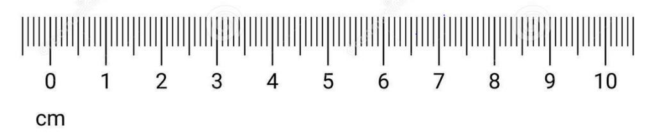

10

cm



1

d

m

**10 cm = 1 dm (**10 centimetri ir 1 decimetrs)

**1 dm = 10 cm (**1 decimetrs ir 10 centimetri)

**1m = 100 cm = 10 dm**

**12 cm = 1 dm 2 cm 1 dm 2 cm = 12 cm**

**LAIKA MĒRVIENĪBAS**

**gads = 12 mēneši**

**1**

**mēn. = 1g.**

**12**

**Janvāris**

**Februāris**

**Marts**

**Aprīlis**

**Maijs**

**Jūnijs**

**Jūlijs**

**Augusts**

**Septembris**

**Oktobris**

**Novembris**

**Decembris**

**Nedēļas**

**dienas**

**Pirmdiena**

**Otrdiena**

**Trešdiena**

**Ceturtdiena**

**Piektdiena**

**Sestdiena**

**Svētdiena**

**DIVU DARBĪBU IZTEIKSMES. IEKAVAS.**

19 – 7 + 2 = 12 + 2 = 14

1) atņemšana 2) saskaitīšana **pēc kārtas**

## – (7 + 2) = 19 - 9 = 18

1) (darbība iekavās) 2) atņemšana

## (19 – 7) + 2 = 12 + 2 = 14

1) (darbība iekavās) 2) saskaitīšana

**LĪNIJU VEIDI**

|  |  |
| --- | --- |
| **Taisne** |  |
| **Liekta līnija** |  |
| **Lauzta līnija** |  |
| **Stars** |  |
| **Nogrieznis** |  |

**PULKSTENIS**

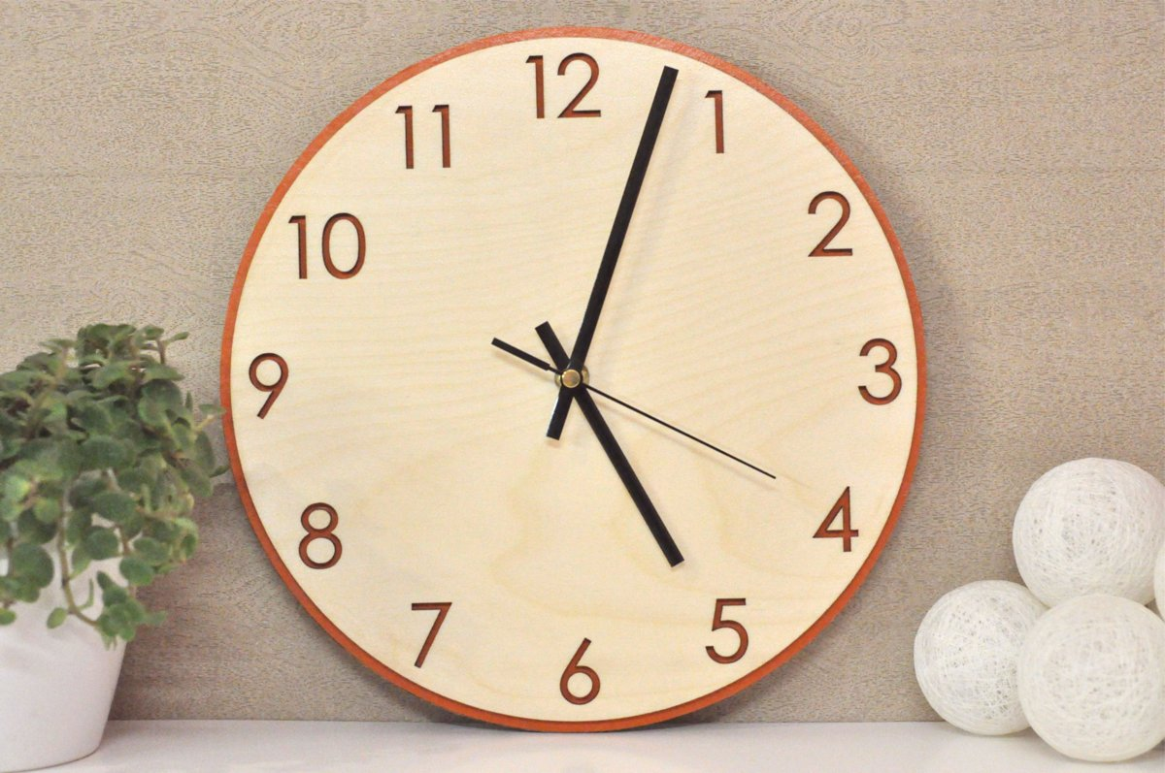

Minūšu rādītājs

**Stundu rādītājs**

1 stundā ir 60 minūtes **1 h = 60 min**

1 diennaktī ir 24 stundas **1 d = 24 h**